Ghana is located in Africa near the Equator
It is very HOT there!
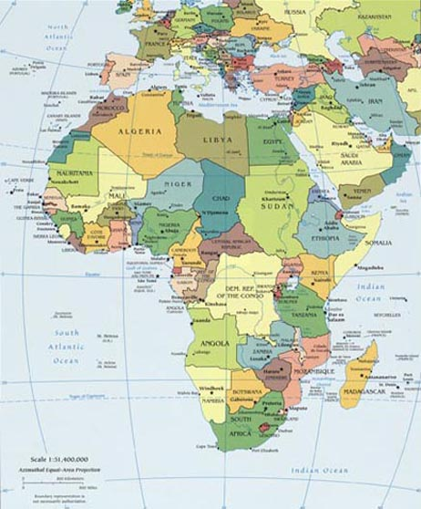
The distance between is 3,300 miles!
This line is called the Equator. It is very hot on the equator.
Ghana is here!
We are here!

This is a map of Ghana
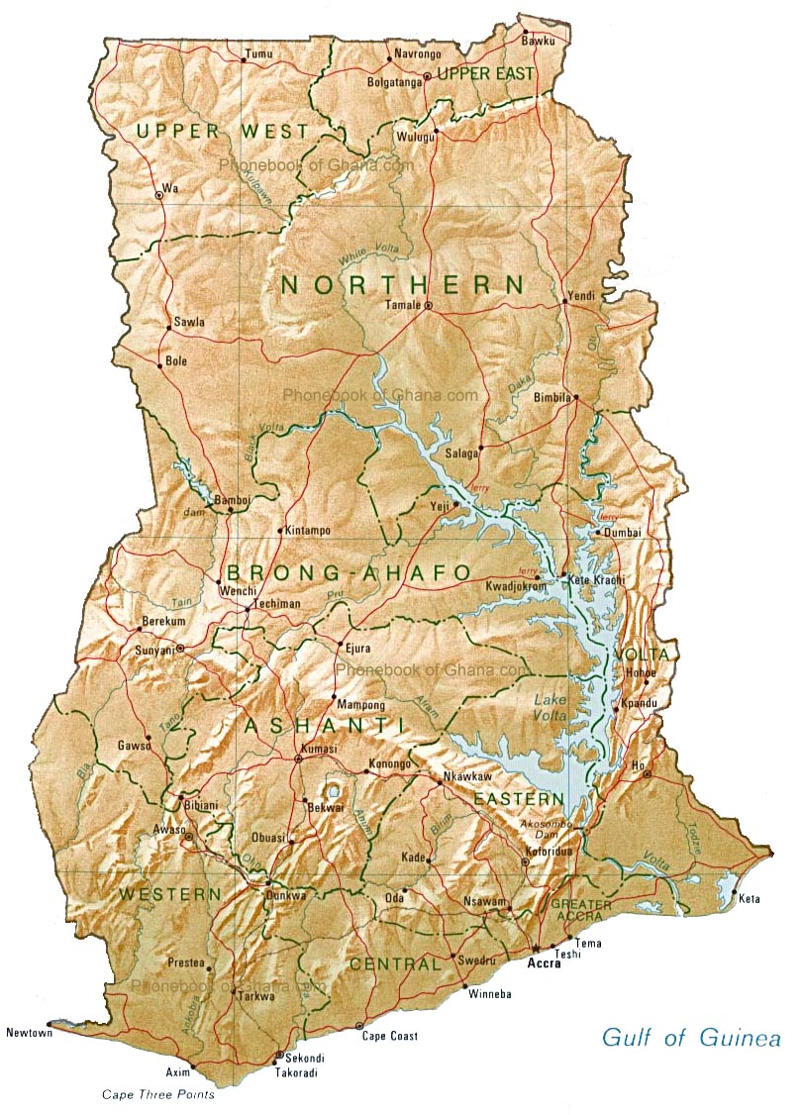
Accra the capital
Fievie Village School
There are 4 main tribes in Ghana: Akan, Ewe, Ga, and Mole-Dagomba.
Accra is the capital of Ghana. Fievie village is located in the Volta region of Ghana, near Sogakope where the people are predominantly Ewe. There is a red ring to show you where it is.
50 different languages are spoken in Ghana and the National Language is…. English!
What is your Ghanaian Name?
That depends on which day of the week you were born!
Day born
 | Male name | Female name
Monday | Kwadwó | Adwoa
Tuesday | Kwabená | Abenaa
Wednesday | Kwakú | Akua
Thursday | Yaw | Yaa
Friday | Kofí | Afia, Afua
Saturday | Kwámè | Ám̀ma
Sunday | Akwasí | Akosua
Kofi Annan is a famous Ghanaian who was head of the United Nations for many years.
Kwame Nkrumah was the first President of Ghana when it became independent from the UK in 1957
On which days do you think they were born? *
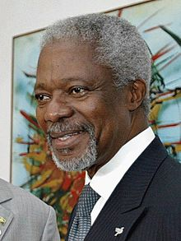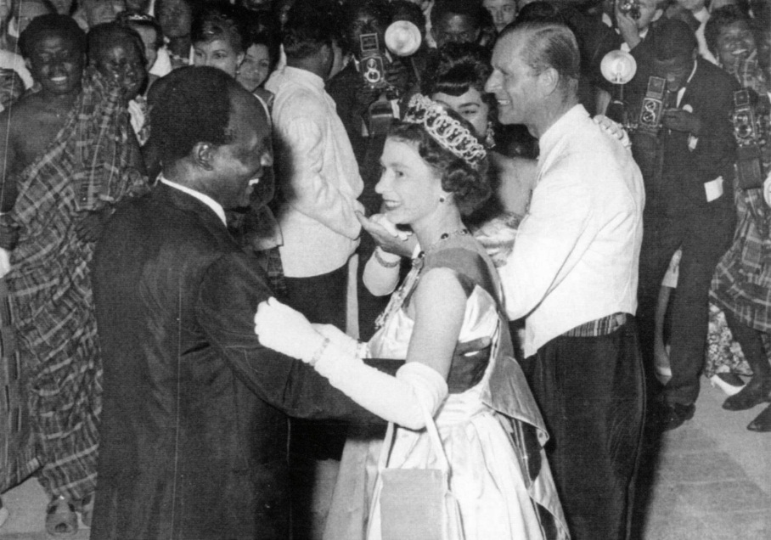
Kofi Annan Kwame Nkrumah dancing with Queen Elizabeth II

* Answer: Kofi Annan was born on Friday and Kwame Nkrumah was born on Saturday
+How do Ghanaian’s eat?
With chopsticks? With a knife and fork? With their right hand?
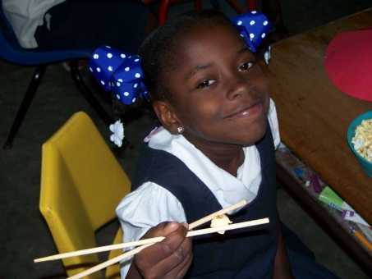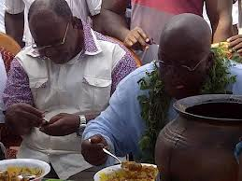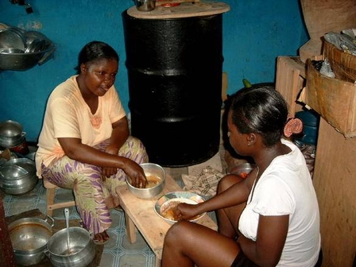
+ Answer: with their RIGHT hand. Try eating with your hand, it’s quite difficult for some things but it saves on washing up!
Ghanaian people are very polite. When you say “hello” you must always ask how they are and how their family is, no matter how much of a rush you are in.
Ghanaian’s have a special handshake, particularly used for friends. You shake hands and “click”!
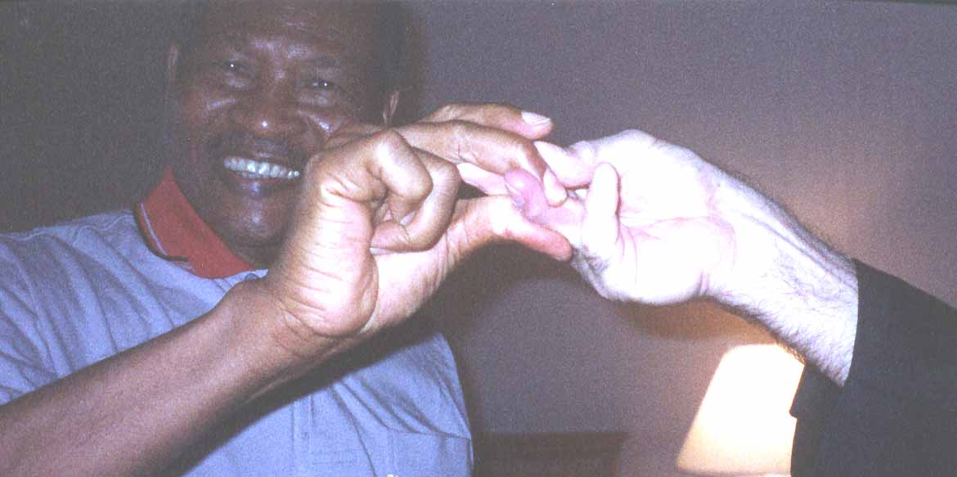
You take your shoes off inside a Ghanaian house and people in Ghana don’t smoke!
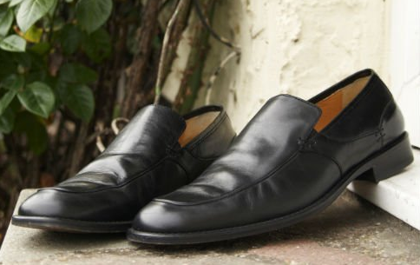
You use your right hand for everything (shaking hands, eating, handling money, etc.) and your left hand is only for wiping your bottom! This is actually common in many parts of the world.
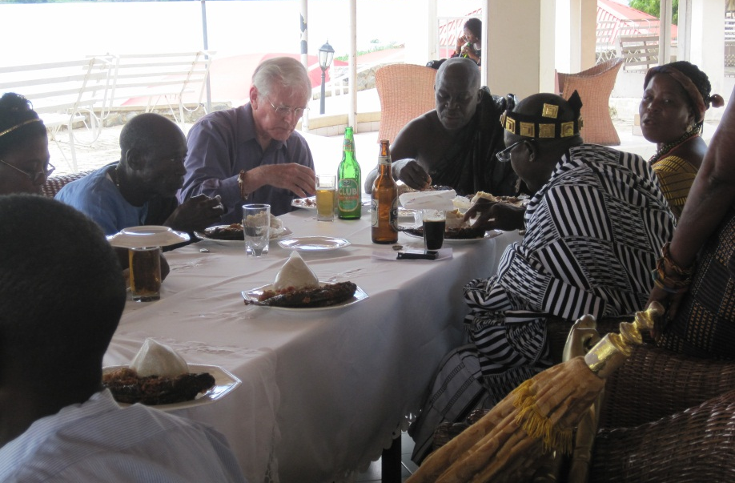
Ghanianan’s carry everything on their heads. It’s more difficult than it looks.
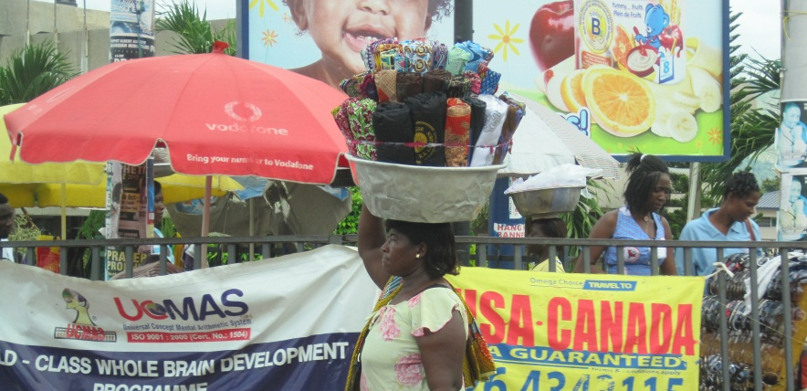
Ghana Currency is the Cedi (sehdi) and Pesewa (pehsaywah). They are like our pounds and pence.
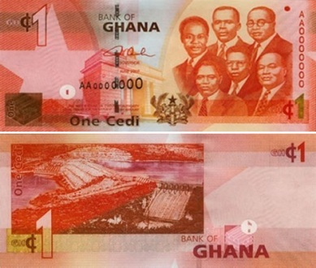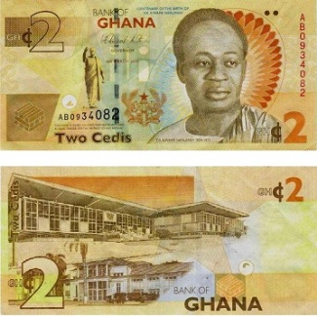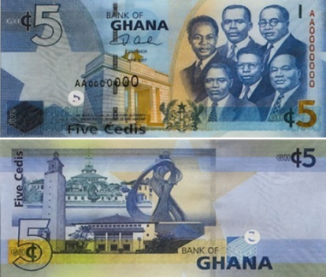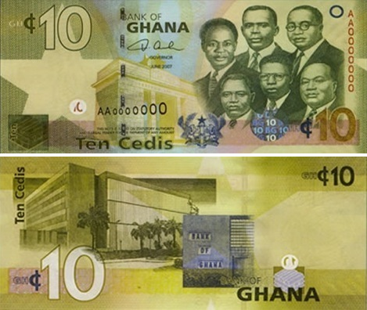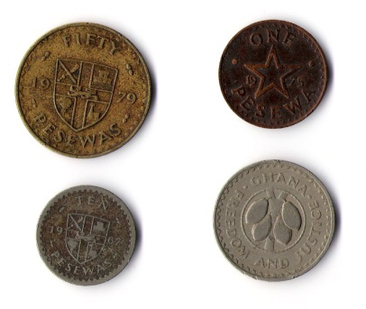
Cedi notes Pesewa coins

Anansi Stories
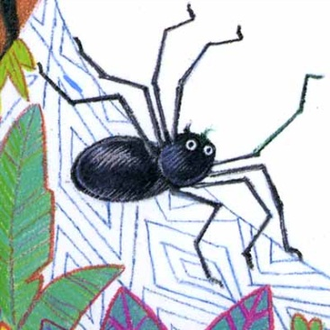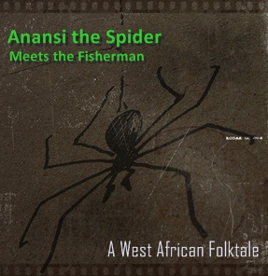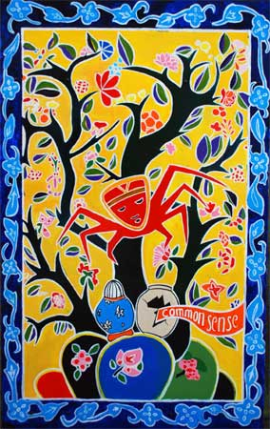
There are lots of stories about Anansi the spider. He is a clever trickster like our Brer Rabbit. He is always outwitting other animals and getting all the best things for himself.

Food
Ghanaian food is delicious but very peppery hot (lots of chillie). They eat:
Plantain (big bananas), Casava, Yam (like potato) and Maize (corn) which are made into Kenke, Banku & Fufu. They eat these with okra, beans, fish and goat in stews. They eat & drink coconut too.
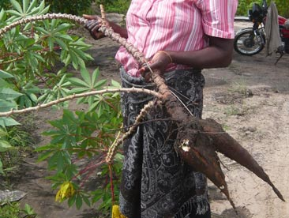
Casava Coconut to drink Yam
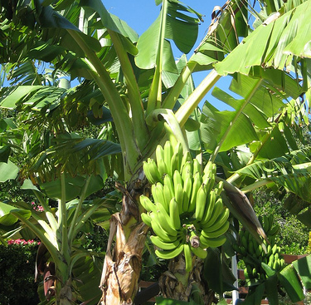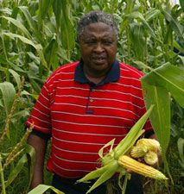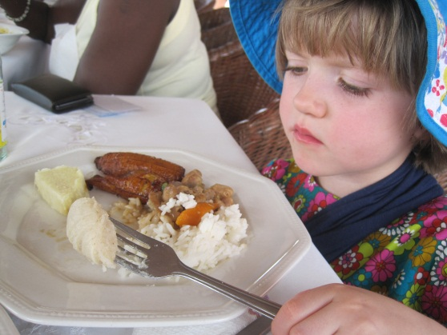
Plantain (like banana) Maize (sweet corn) Genevieve eats yam, banku & plantain

Arts & Crafts
People in Ghana have beautiful cloth and beads. The traditional cloth is called Kente Cloth.
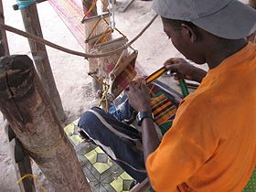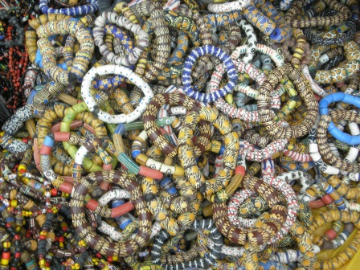
Beads are very important. In the old days they were used like money. They are made from ground glass from old bottles mixed with coloured powders. Beads are handed down from generation to generation, from mother to daughter and giving a present of Ghanaian beads is very special.
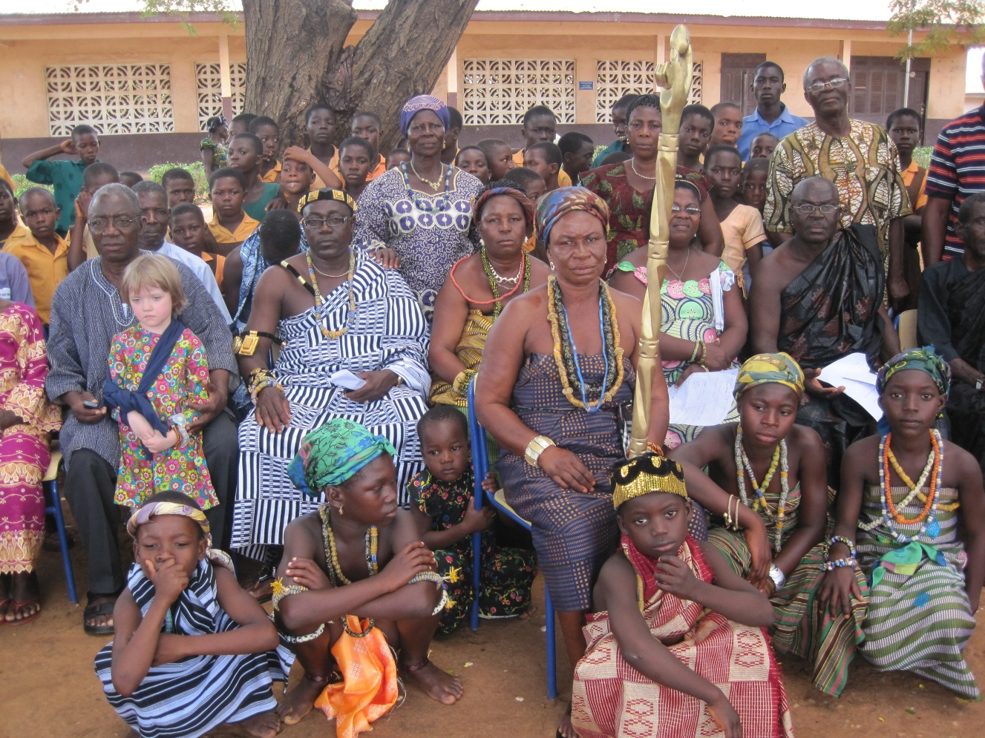
Look at all the different beads that people are wearing in this photograph in front of the school especially the dancing boys and girls at the front, the paramount Chief and the Queen Mother.

Fievie Village
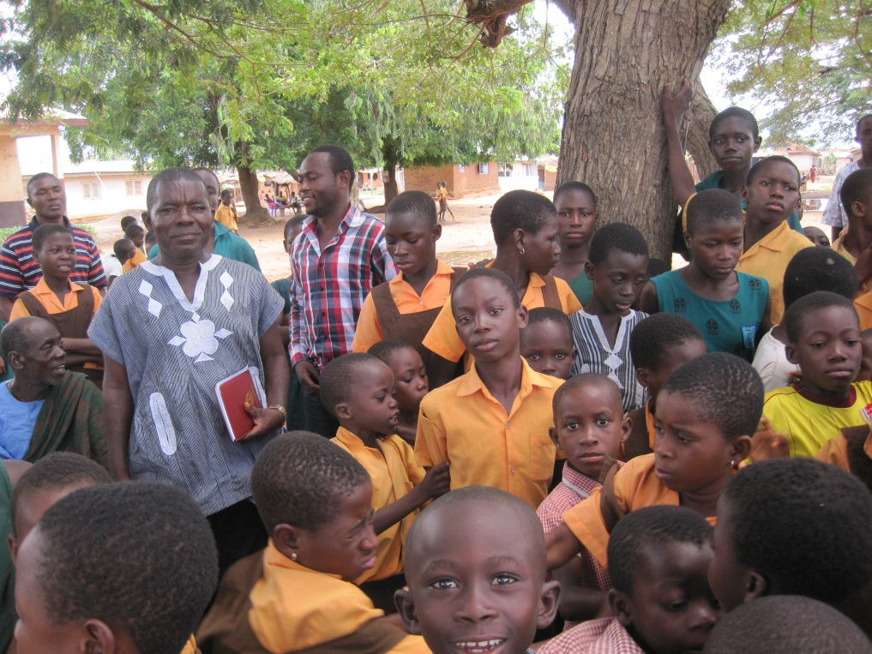
Pupils in school uniform (brown & orange) & Mr Justice Awlayi the Assistant Head Teacher (centre back). The school has about 200 pupils. They liked the books we brought them and everyone loved the card that you made them!
The people in the village are quite poor, they live in basic houses with straw or tin roofs and mud or brick walls and they don’t have running water. They have to walk 1km to get water but it’s very dirty and can make the children, especially the babies, very ill.
